EGR2312 Lab Experiment N°2
The Stress-Strain curve and Young’s Modulus

- Objective :
In this experiment, we will build on what we learned in experiment 1. In addition to measuring the stress withstood by a specimen, we will also measure the strain it is undergoing. These two values will allow us to plot the stress-strain curve and obtain the specimen’s Young’s modulus.
- Measuring Strain
You already know how to measure stress (by measuring the displacement of the springs). Let’s see how you can measure strain.

- Definition
Strain $ε$ is a measure of deformation of a material after it suffered from stress. In our case, strain measures the elongation of our specimen due to tensile stress. Strain is defined as the ratio of elongation (δ) to the original of length, it is a dimensionless parameter.
$ε= \frac{L_{t}[m]- L_{0}[m]}{L_{0} [m]}= \frac{δ [m]}{L_{0} [m]}$ (1)

L_{t} is the length of the specimen after applying tensile stress at a time t
L₀ is the initial length of the specimen with no stress applied.
Because we are working with tensile stress, strain $ε$ will always be positive (the specimen is expanding), but for compressive stress, strain is negative (the specimen is shrinking).

- How to measure strain
First, measure the length L₀ of your specimen.
To measure strain, we need to measure the elongation $δ$ of the specimen after we apply a tensile force.
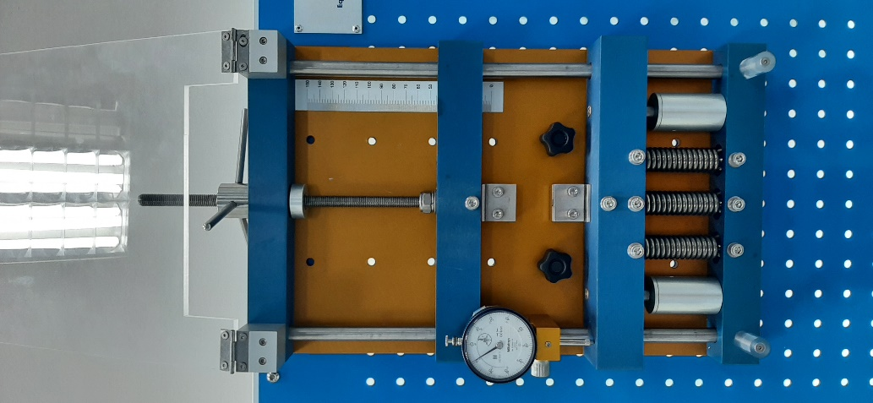

Graduated scale
After you turn the wheel, this upper anchoring device goes up, increasing with a distance L_{up}. This distance L_{up} is the elongation of the springs plus that of the specimen (see equation 2).

The lower anchoring device also goes up. It increases with a distance equal only to the elongation of the springs, ∆L, measured using the dial gage.

The figure above illustrate
Equation 2:
L_{up} = $δ$ + ∆L ( 2)
We know how to measure ∆L using the dial gauge. L_{up} can also be measured using the graduated scale, or by taking into consideration that each 1/3 of a turn of the wheel equals to an increase of 0.5mm.
This means that we can obtain the elongation $δ$ and thus the strain $ε$.
$δ$ = L_{up} - ∆L ( 2)
- Preparing your lab report
- Measure the stress and strain for steel and aluminum. Report your results in the tables below.
Steel
L₀ = mm
RC₀ = mm
A = mm²
RC (mm) | ∆L = RC₀ – RC (mm) | L_{up} | F(N) | σ (N/mm²) | $δ$ (mm) | $$ε$$

Table 1: Experimentation values and calculation for the specimen made of steel

Aluminum
L₀ = mm
RC₀ = mm
A = mm²
RC (mm) | ∆L = RC₀ – RC (mm) | L_{up} | F(N) | σ (N/mm²) | $δ$ (mm) | $$ε$$

Table 2: Experimentation values and calculation for the specimen made of Aluminum.

- Draw the corresponding stress-strain (σ-ε) charts for each material.
- From the stress-strain chart, what is the Young’s modulus of each material in MPa? (fit your data points with a line and display its equation).
- Which material has higher young’s modulus? Why?
- Which material supports higher stress before a permanent strain is generated in its structure? Why?

